Task 3:

1. Query to Retrieve event information for a specific event:

Output:

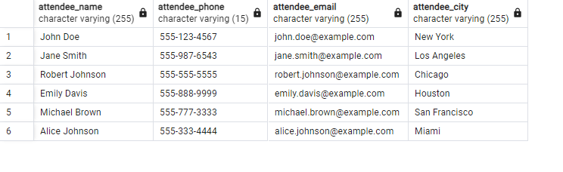

1. Query for an attendee list for a specific event

Output:

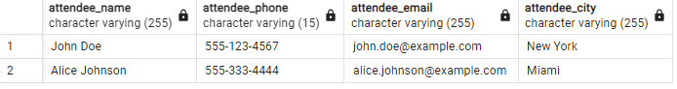

1. Query for the total number of attendees and the total revenue for an event

Output:

